Landed Cost Voucher
Img1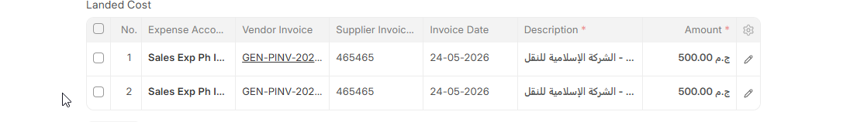
- In the cost table, it duplicates the same vendor invoice, as we notice the supplier invoice NO is the same for the two entries. As in img (1)
- requires multiple fields in it as following: Image 2
Image 2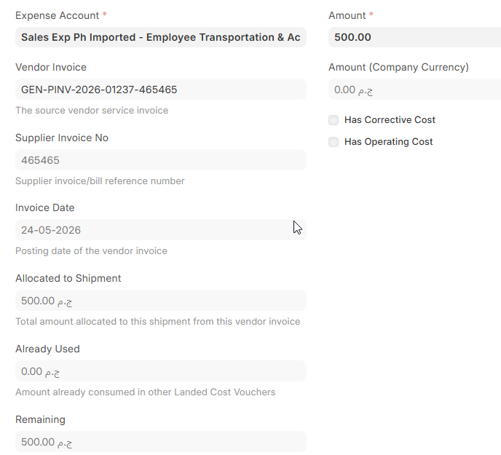
  - Get the total invoice amount -> field 1
  - The total cumulative amount that used in others landed cost vouchers if exist. -> field 2
  - Adding validation to not to exceeding the amount of the invoice. The total landed costs for the same vendor invoice should not exceed the amount of it.
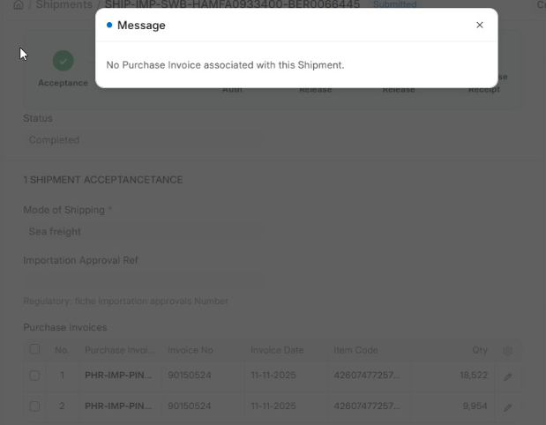

Shipments
- Shipments doctype in a live site, throw this error and don’t update the shipment ref in the invoice associated to it.
- Cannot cancel or remove it in the live site

Purchase receipt
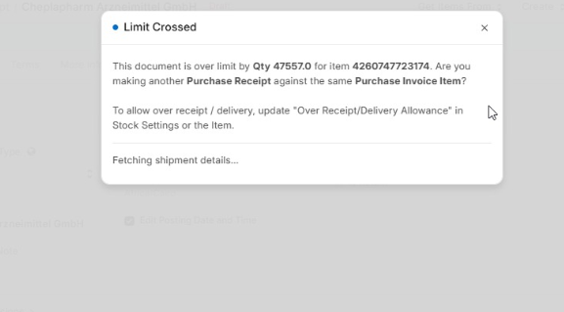
- When attempting to receive a shipment linked to an invoice, the system throws a quantity validation error during submission, even though the quantity is identical to the quantity on the invoice. As a result, the shipment cannot be submitted. As shown in the following img
- When the invoice has only one entry, the system raises an error in the "Serial/Batch Bundle" field, stating that the bundle is linked to the purchase invoice. The invoice can only be submitted after the user manually clears the "Serial/Batch Bundle" field.
- Finally, the system no longer supports creating a Purchase Receipt from a Purchase Invoice. It only allows creating a Purchase Receipt from a Shipment. If that's the case, how are we supposed to receive locally purchased goods? When trying to create a Purchase Receipt from a Purchase Invoice, the system creates a Purchase Receipt with an empty Items table.

Purchase invoice

Update stock button makes a serious mistakes in data entry, for that doctype
So we need to changed to be unchecked by default .

